COMP 3612
Assignment #2: Single-Page App in JavaScript

Version: 1.0 Oct. 21, 2026
Assign 2: Due Saturday November 21, 2026 at midnightish

Overview
This assignment provides an opportunity for you to demonstrate your ability to work with JavaScript. The application you will be creating is a Single-Page Application to view products.

You can work in pairs or by yourself. Don’t delay finding a partner; if you cannot find a partner to work with, don’t ask me to be in a group of 3, you will have to work alone. The assignment is very doable by one person, but it will be a more pleasant experience sharing the work with another.

Beginning
It is your responsibility to read all the assignment instructions thoroughly and carefully. If you are unclear about something, ask me. But before you do, read the material in question again!

Grading
The grade for this assignment will be broken down as follows:
Visual Design 15%
Programming Design and Documentation 10%
Functionality (follows requirements) 75%

Requirements
This assignment consists of a single HTML page (hence single-page application or SPA) with the following functionality:
- You can use a third-party CSS library/framework (indeed I would encourage you to use one). Tailwind CSS is a great thing to have on your resume, but it does have a bit of a learning curve (Lab7b in your gumroad package can help you quickly learn its essentials). Be careful though that your CSS library is not using/requiring its own JavaScript library as well. Some popular CSS libraries (e.g., Bootstrap) include their own JavaScript libraries to do fancy things with select lists, modals, etc. You are NOT allowed to include these so be sure you don’t have any extra <script> tags from your CSS library!
- Your assignment should have just a single HTML page which must be named index.html.
- The assignment should have five main views (Home, Browse, Single Product and Shopping Cart) and one dialog/popup (About Us). When the program first starts, display the Home view.
- The source of data will initially be in the provided json file (I have provided a formatted and a compact version; you should use the compact version as it will be faster to load). More detail will be provided below. Later you will instead use fetch against an API for the data.

- You must write your own JavaScript. That is, no jQuery, no Bootstrap, no other third-party JavaScript libraries, and certainly no AI-generated JavaScript. You have all the knowledge you need from the lectures and the JavaScript labs (Lab8, Lab9a, Lab9b, and parts of Lab10) to complete this assignment. If you do find yourself, however, making use of some small snippet of code you found online (and I do mean small), then you must provide references (i.e., specify the URL where you found it) via comments within your .js file. Failure to properly credit other people’s work in your JavaScript will result in a zero grade. Using antediluvian JavaScript found online will also result in lower marks. There is no need to credit code you found in the labs or lectures.
- Header / Footer. All your views will contain the same header / footer. Another way of saying this is that you will be changing the content between the header and footer. The image below demonstrates the functionality required. The links are not URLs to other html files; instead, they indicate that your SPA must display a different view.
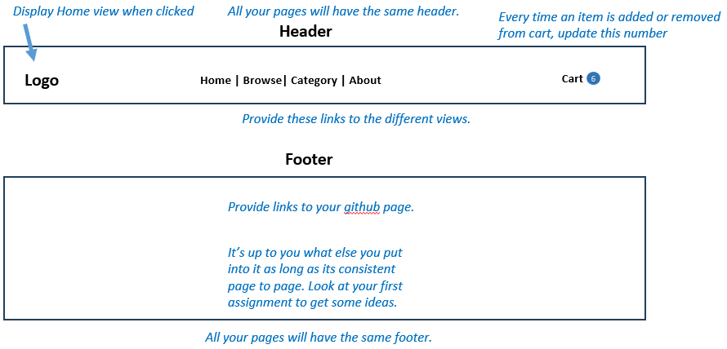

- Home View. You will implement a page with similar functionality as that described below. As you can see, I’ve left it up to you in terms of what content to put on this page. The featured products should be linked appropriately to the single product page.
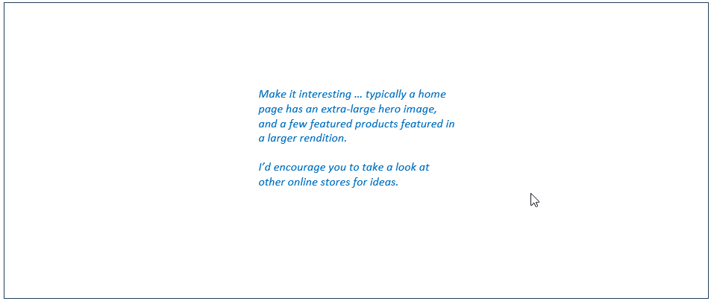
- Category View. You will implement a page with similar functionality as that described below.

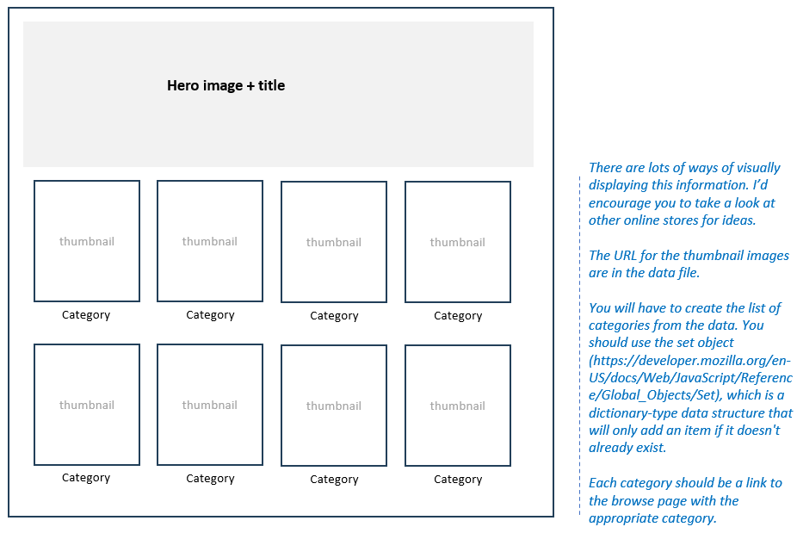
- Browse View. This is the heart of the assignment. Your view must be able to display products that match a variety of different criteria and which has the functionality listed below.
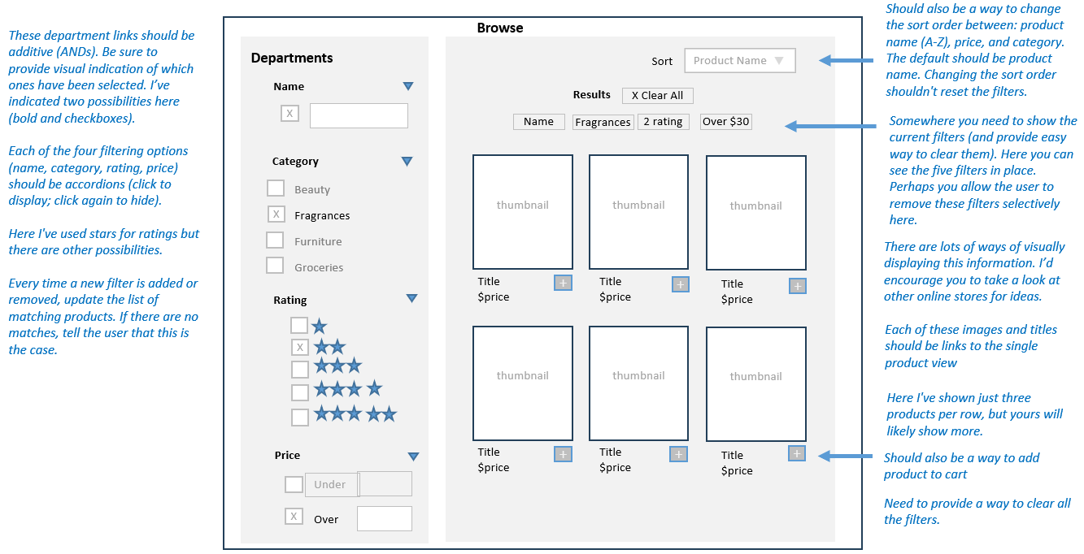

- Single Product View. Display details for a single product with the following functionality.
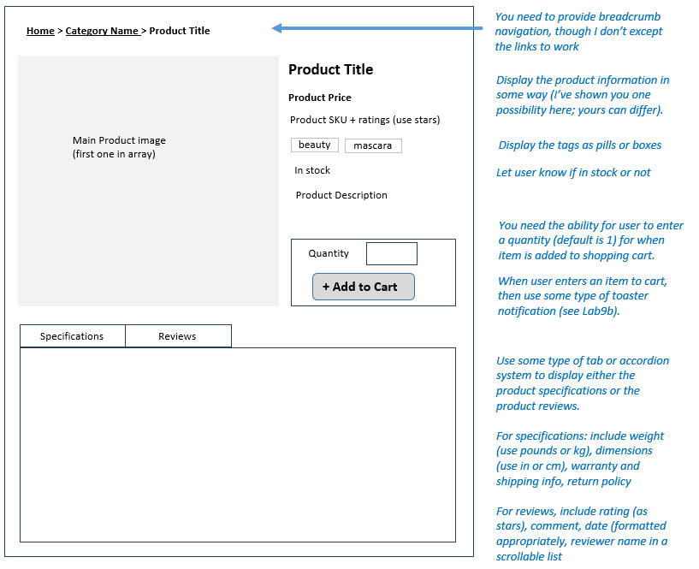

- Shopping Cart View. Display current content of shopping cart with the following functionality. The cart must persist; that is, if I close the application and then restart it, the cart will still be there. You must use localStorage (see lab10) to implement this feature.
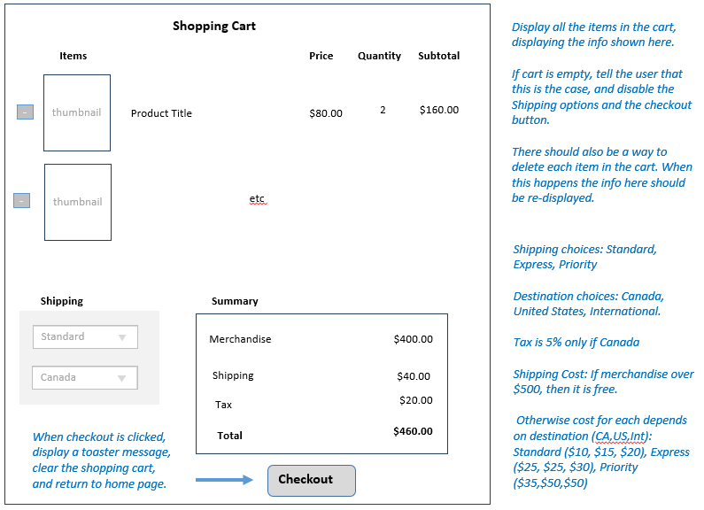

- About Us Dialog/Popup. Display an about dialog that has info about the assignment, the technologies you are using, info about yourself, a link to the github repo, etc.
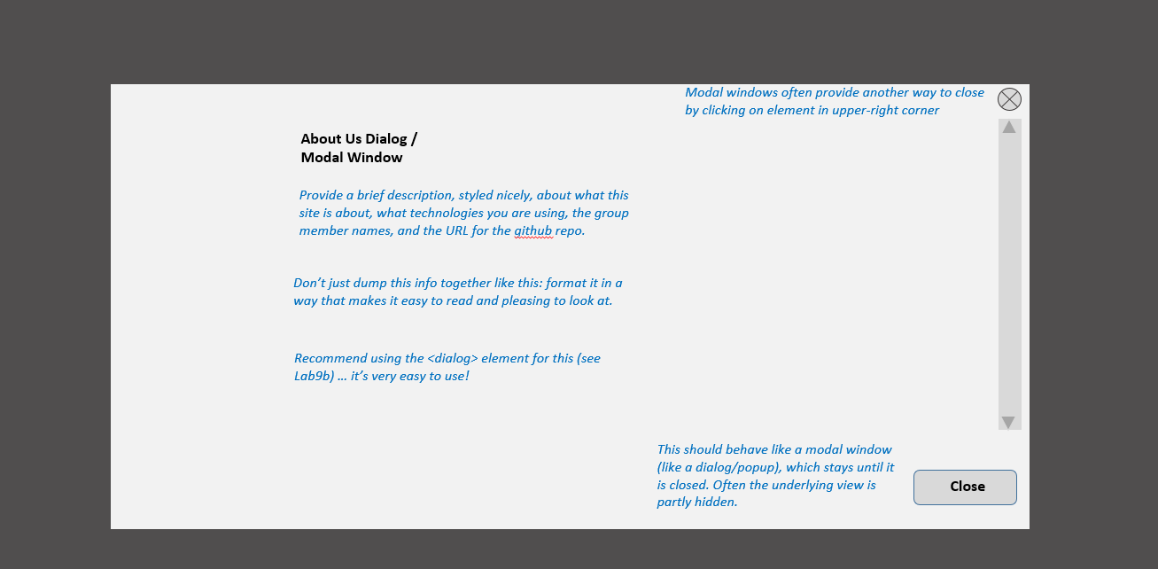

Testing
Every year students lose many easy marks because they didn’t read the requirements carefully enough. When your assignment is getting close to done, I would recommend going through each requirement step and carefully evaluate whether your assignment satisfies each specified requirement. After you upload to your host, test again!!!

Handling Data
You will be consuming/fetching data from the API URL below. Your code must use fetch when it is handed in. But since we won’t learn how to use fetch until mid-November, you can import the provided JSON data file before then by adding this code to the top of your JS file:
import config from './data-minifed.json' with { type: 'json' };

Eventually, you will need to switch to asynchronous fetching of the data using the following URL to get all the data:
https://dummyjson.com/products?limit=100
When getting just a single product, instead use the following URL:
https://dummyjson.com/products/#
where # is the product id.
This approach means hosting the application is trivial, in that you can host on any static service (such as github pages).
To see the content of this data, I have provided the data-pretty.json file for you to examine without fetching.
Make sure you are only requesting/fetching all the data ONCE! To improve the performance of your assignment (and reduce the number of requests on the server), you must store the data in localstorage after you fetch it from the API (see Exercise 10.11 in Lab 10). Notice that you have to use JSON.stringify to create a JSON string version of the array and then saving that in localstorage; similarly, after you retrieve it from localstorage, you will need to uses JSON.parse() to turn it into an array. Your page should thus check if this data is already saved in local storage: if it is then use local data, otherwise fetch it and store it in local storage. This approach improves initial performance by eliminating this first fetch in future uses of the application. Be sure to test that your application works when local storage is empty before submitting (you can empty local storage in Chrome via the Application tab in DevTools). Failure to implement this functionality will result in a loss of marks so don’t neglect it.

Submitting and Hosting
Your assignment source code must reside on GitHub and reside on a working public server (in this case GitHub Pages).
GitHub Pages works in conjunction with git and github. You push your html/css/images to github repo; and then push to the host. The instructions for doings so can be found at:
https://docs.github.com/en/pages/getting-started-with-github-pages/creating-a-github-pages-site
It is up to you whether you want your pages to be public (available to the world) or private (available to only those with access to your github repo).
If you are using a private repo, you must add me as a collaborator!
I would strongly recommend getting your hosting to work a few days before the due date. It’s okay if your assignment is still not complete at that point: the idea here is to make sure hosting works ahead of time!
When your hosting is working and the assignment is ready to be marked, then send me an email with the following information:
- The URL of the home page of the site on github pages.
- The URL of the github repo so that I can mark the source code. If your repo is private, then add me as a collaborator.

Hints
- This assignment requires swapping different views. You should implement each view in its own container, e.g.,
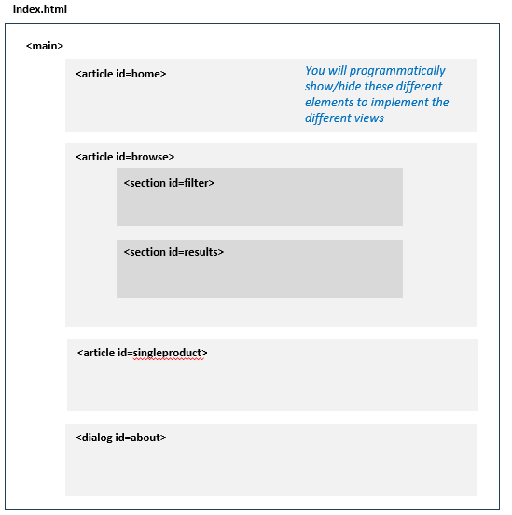
- Remember that JSON and JavaScript are case sensitive. For instance, it is easy to type in Category and it won’t work because the JSON field is actually category.
- Your index.html file will include the markup for all your views. Your JavaScript code will programmatically hide/unhide (i.e., change the display value) the relevant markup container for these views.
- I would recommend implementing the Single Product View first and then the Shopping Cart View second. The Browse View is the most complex so maybe do that third (though some programmers prefer to tackle the most complex use case first).
- Most of your visual design mark will be determined by how much effort you took to make the views look well designed. Simply throwing up the data with basic formatting will earn you minimal design marks.
- Most years, students tend to get low marks on the design side of the assignment. I would recommend looking at other sites on the internet and examine how they present data. Notice the use of contrast (weight, color, etc) and spacing.
- Most of your programming design mark will be based on my assessment of your code using typical code review criteria. For instance, did you modularize your code using functions? Are your functions too long? Is the code documented? Do you have a lot of code duplication (you shouldn’t … if you are copy+pasting code, that should tell you that you are doing things wrong from a design standpoint)? Did you make use of object-oriented techniques? Are variables and functions sensibly named? Is your code inefficient (e.g., fetching the same data repeatedly)? Are you using outdated JavaScript techniques (e.g., inline coding, var, XmlHttpRequest, etc)? Is the code excessively reliant on found code from Stack Overflow, etc?
- You will need to find some way of handling routes. For instance, how will your JavaScript “know” whether to display home view or single product view or shopping cart view? Ultimately, you will be listening for button / link / list clicks. But on any given page, there will be a lot of them! When I assess the design mark, I will be looking at how you’ve handled this problem. See if you can come up with more generalized solutions to this problem. BTW, one of the advantages of large JavaScript frameworks such as React or Next is that they provide some type of easy way of managing and implementing routes.

